Assignment # 1
Embedded System and Control
Taha Sajid Awan – 22I-2302

1. Introduction
The control design process begins with system modeling, where mathematical models describe the dynamic behavior of real-world systems. These models allow engineers to predict how systems will respond to different inputs, disturbances, and design modifications.
In this report, we explore two major modeling approaches:
- State-Space Representation – a time-domain model suitable for multi-variable systems.
- Transfer Function Representation – a frequency-domain model widely used in classical control.
We first reviewed general modeling principles with a mass-spring-damper system. The concepts are then applied to a practical case study: the automatic cruise control system in vehicles.

2. Background: Dynamic Systems and Modeling
Dynamic systems evolve with time and are often represented by differential equations. For linear time-invariant (LTI) systems, we can represent them in two equivalent forms:
- State-Space Model

- Transfer Function Model (via Laplace Transform)
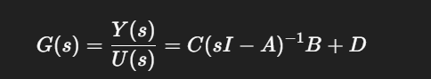
These models form the foundation for system analysis, simulation, and controller design.

- Example: Mass-Spring-Damper System

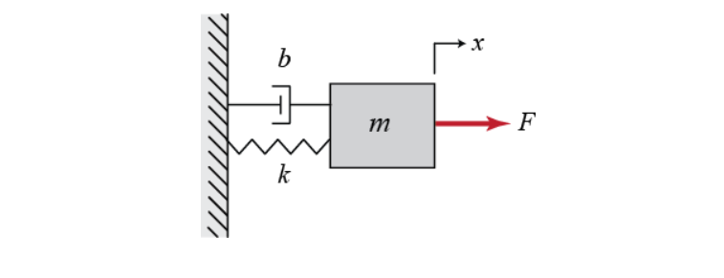
From Newton’s second law:
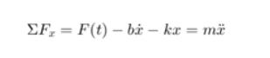
- State-space model:
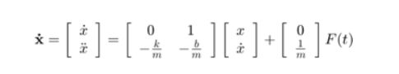
- Transfer function model:
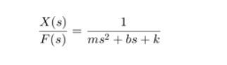
This example demonstrates how mechanical systems can be expressed in both time-domain and frequency-domain forms.

4. Case Study: Cruise Control System

4.1 Physical Setup
Cruise control is a feedback system in vehicles that maintains a constant speed despite disturbances such as wind drag or road slope.
- Input: Control force u applied at the wheels.
- Output: Vehicle velocity v.
- Disturbance: Resistive force bv due to rolling resistance and aerodynamic drag.
For simplicity, the engine and tire dynamics are neglected, and the system is modeled as a first-order mass-damper system.

4.2 Governing Equation
Applying Newton’s second law:

m: vehicle mass = 1000 kg
b: damping coefficient = 50 Ns/m
The output equation is:
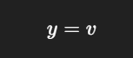

4.3 State-Space Representation
Since the system is first-order, velocity is chosen as the single state variable:
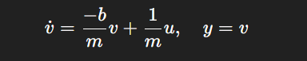
State-space matrices:
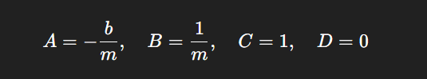
MATLAB implementation:
m = 1000;
b = 50;

A = -b/m;
B = 1/m;
C = 1;
D = 0;

cruise_ss = ss(A,B,C,D);

4.4 Transfer Function Representation
Taking the Laplace transform:
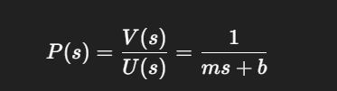
This is a first-order transfer function, where:
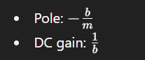
MATLAB implementation:
s = tf('s');
P_cruise = 1/(m*s + b);

4.5 Interpretation
- The cruise control system is inherently stable, since its pole lies in the left half of the complex plane.
- The vehicle behaves like a first-order system with a time constant of τ=m/b
- A larger vehicle mass m → slower response.
- Higher damping b → more resistance, requiring more input force.

5. Conclusion
This assignment demonstrated how to model a vehicle cruise control system using both state-space and transfer function methods.
- The state-space approach clearly shows system dynamics in the time domain and is useful for modern control design.
- The transfer function approach simplifies frequency-domain analysis and stability assessment.

What I learnt from the Assignment
- Dynamic Systems & Modeling
  - Real-world systems (like cars, robots, machines) don’t stay still—they change with time.
  - To study them, we make mathematical models (equations) that describe how inputs (like throttle) affect outputs (like car speed).
  - Two big ways to represent such systems:
    - State-Space Representation (time-domain):
      - Focuses on internal states (like velocity, position).
      - Useful for multi-variable and modern control systems.
    - Transfer Function Representation (frequency-domain):
      - Focuses on input-output relation.
      - Great for analyzing stability and frequency response.
- Mass-Spring-Damper Example
  - This simple system was used to show how physical laws (Newton’s second law) can be turned into:
    - Differential equations.
    - State-space form.
    - Transfer function form.
  - The key lesson: any physical system can be modeled mathematically in different but equivalent ways.
- Cruise Control Case Study
  - A real-world application of control theory.
  - Goal: Keep vehicle speed constant despite disturbances (wind, slope).
  - Modeling simplification: treated as a mass-damper system (mass = car, damping = drag/friction).
  - Key takeaways:
    - State-Space Form: Shows how velocity evolves with applied force.
    - Transfer Function: Easier to analyze stability and response speed.
    - Stability Insight: Since the pole lies in the left half-plane, the system is stable.
    - System Behavior:
      - Heavier car (larger mass) → slower response.
      - More damping (drag/resistance) → needs more force to maintain speed.
- Practical Understanding
  - Why both methods?
    - State-space → better for complex/modern systems with multiple variables.
    - Transfer function → simpler and widely used in classical control.
  - Why cruise control?
    - A relatable, real-world feedback system.
    - Demonstrates how control theory ensures stability and performance in vehicles.

